# **Build and Run Java Mercury API from Eclipse**

**_________________________________**

# **Introduction**

This document describes how to build Java API and run sample application from Eclipse.

# **Instructions to build JAVA API**

1. Download Eclipse IDE for respective OS platform(Windows/MAC/Linux).
2. Install Eclipse IDE for Java Developers.
3. Open Java Environment.
4. Download the Mercury API SDK and extract it.
5. Open the project *mercuryapi_nb*(available at path“*SDK\java*”) in Eclipse IDE
6. Right click on the *mercuryapi_nb -> properties -> Java Build Path -> Libraries ->Add External JAR’s -> add ltkjava- 1.0.0.6.jar* (available at SDK/java) -> *Apply and Close*

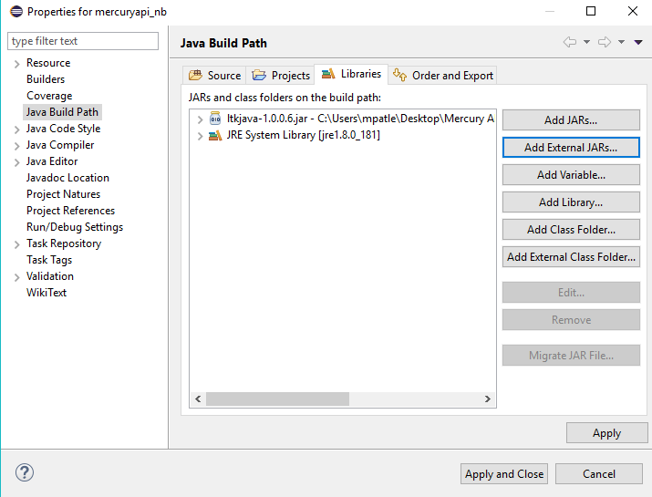

1. Now right click on “*mercuryapi_nb*” and build the project.

# 

# **Instructions to Build and Run Sample Codelet**

1. Open project “*samples_nb*” available at SDK/java.
2. Right click on *samples_nb -> properties-> Java Build Path -> Add External JAR’s -> add mercuryapi.jar, aeitagdecoder.jar and ltkjava- 1.0.0.6.jar(available at SDK/java) -> Apply and Close*

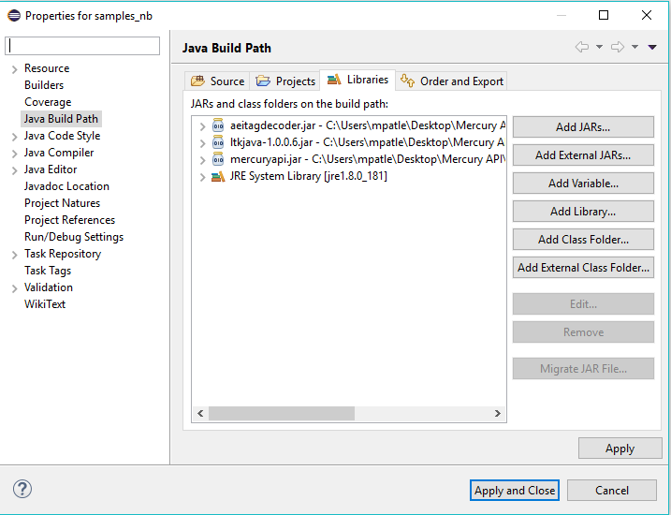

1. Now Build the “*samples_nb*” project.
2. Open the Sample codelet you want to run, click on *Run -> Run Configuration -> Java Application -> Main -> Search for the Main class(i.e Name of smaple Codelet)*.
3. Click on “Arguments” and add the URI under “Program arguments” depending upon the reader you are using

For Example: *tmr:///com19 --ant* 1 for serial readers and“*tmr://<ip address> --ant 1,2*” for Network readers.

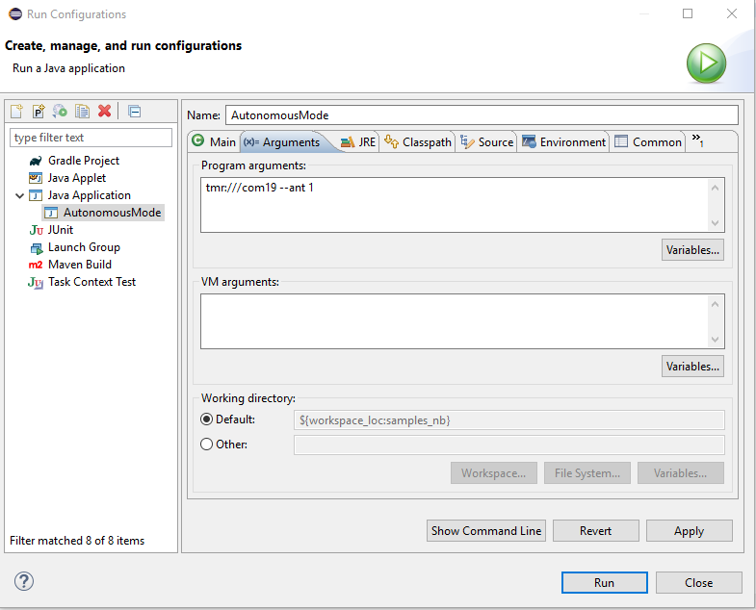

1. Click on Run
2. You can observe the output in console.